**Cloud Computing**

**UE19CS352**

**6th Semester, Academic Year 2021-22**

Week #: 2 Assignment - Kubernetes

Date: 28/2/2022

|  |  |  |
| --- | --- | --- |
| Name :  SUMUKH RAJU BHAT | SRN :  PES1UG19CS519 | Section :  H |

*2a.jpg* Screenshot of kubectl commands and port forwarding

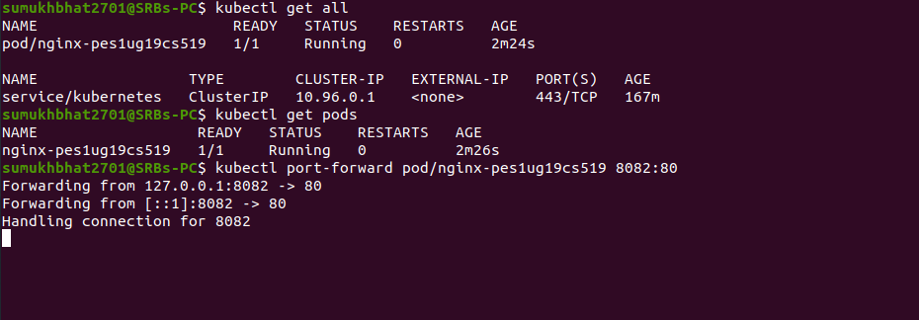

*2b.jpg* Nginx home page access through localhost

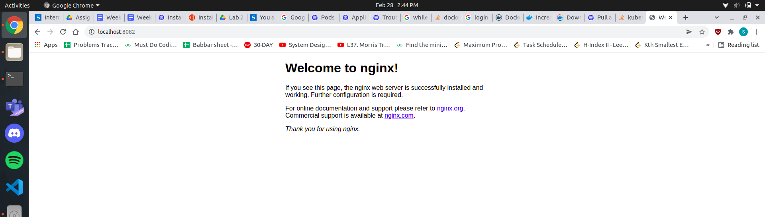

*3a.jpg* Screenshot showing deleted pod and seal healing of pods in a deployment

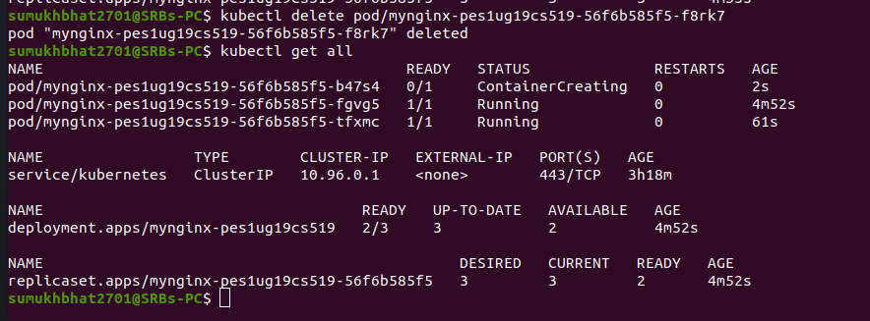

*3b.jpg* Screenshot showing updates and revision history of a deployment

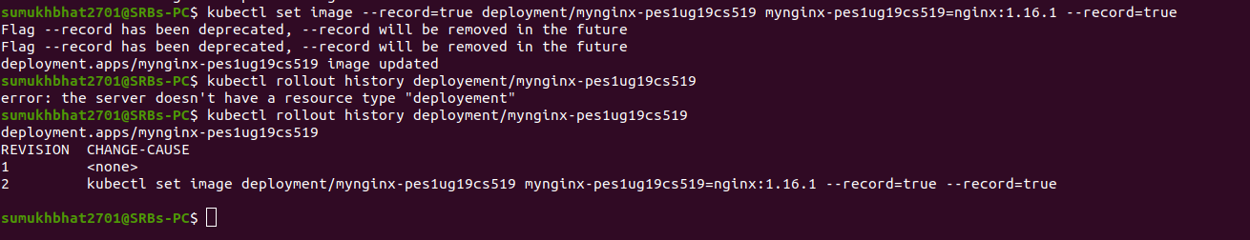

*3c.jpg* Screenshot showing rollback of deployment

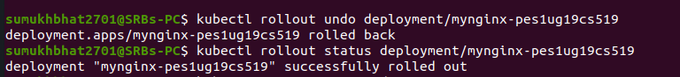

*4a.jpg* Screenshot showing: deployment and service creation, port forwarding, Scaling deployment

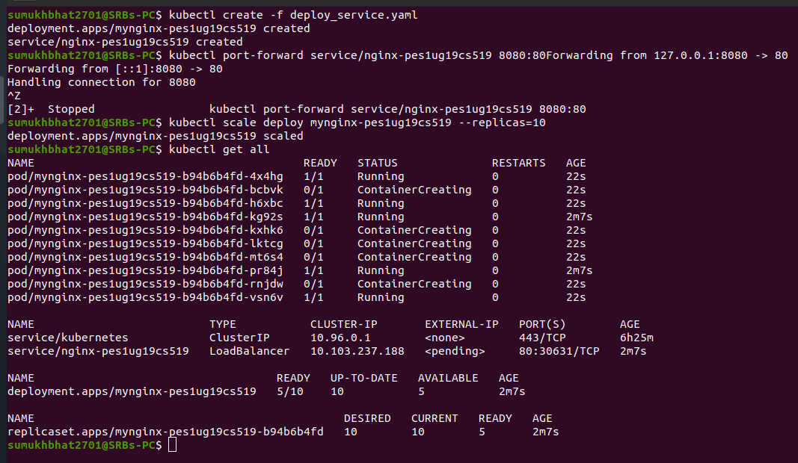

*4b.jpg* Nginx home page access through localhost

